NODE RED SERVICES

|  |  |
| --- | --- |
| DATE | 18 November,2022 |
| TEAM ID | PNT2022TMID50061 |
| PROJECT NAME | REAL TIME RIVER WATER QUALITY MONITORING AND CONTROL SYSTEM |

INITIATING NODE RED:

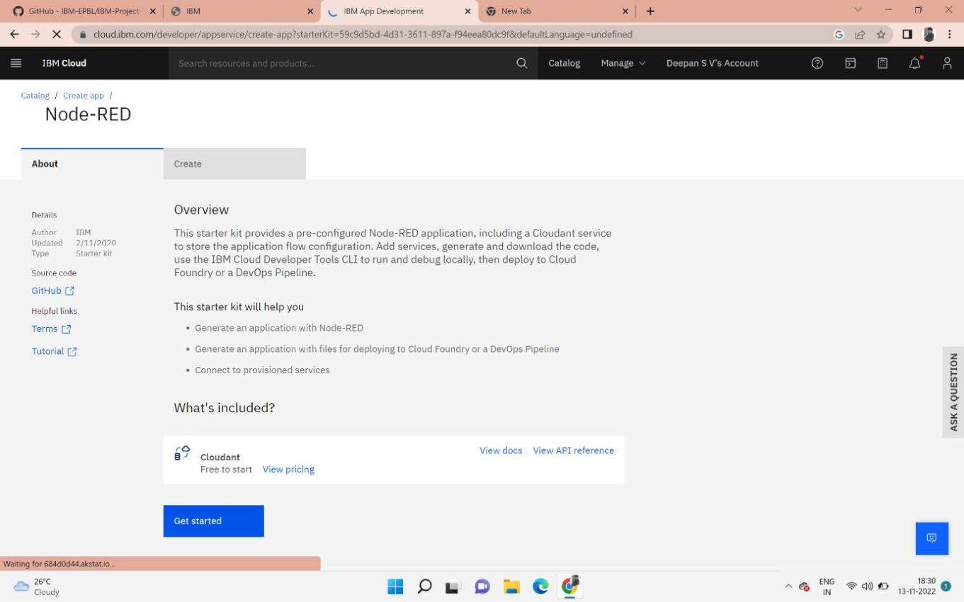

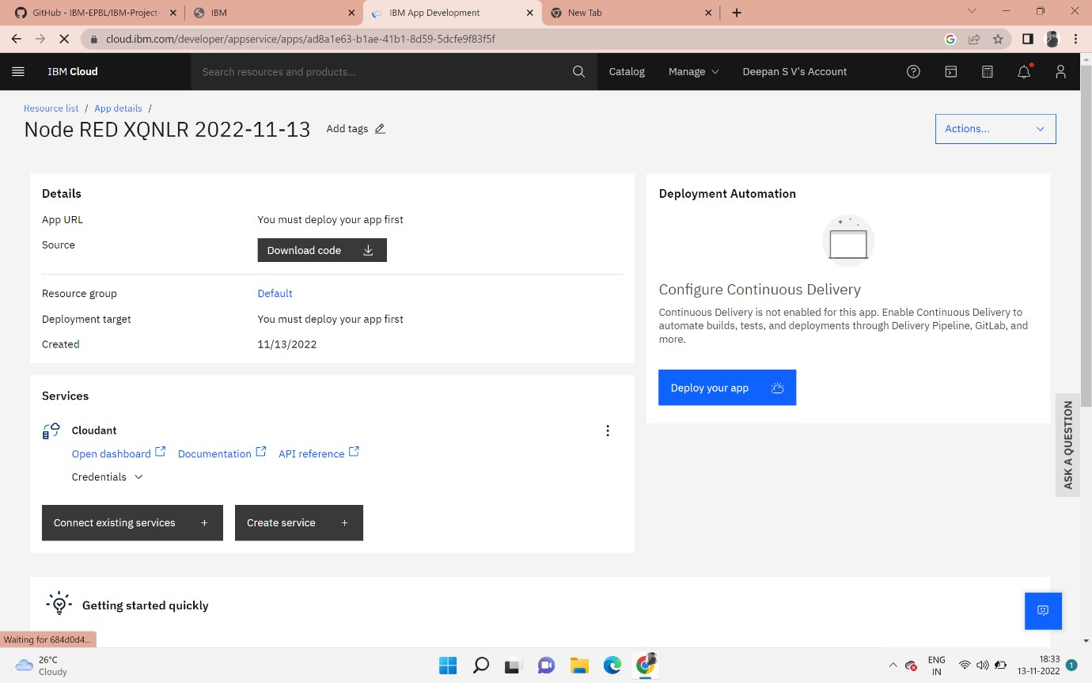

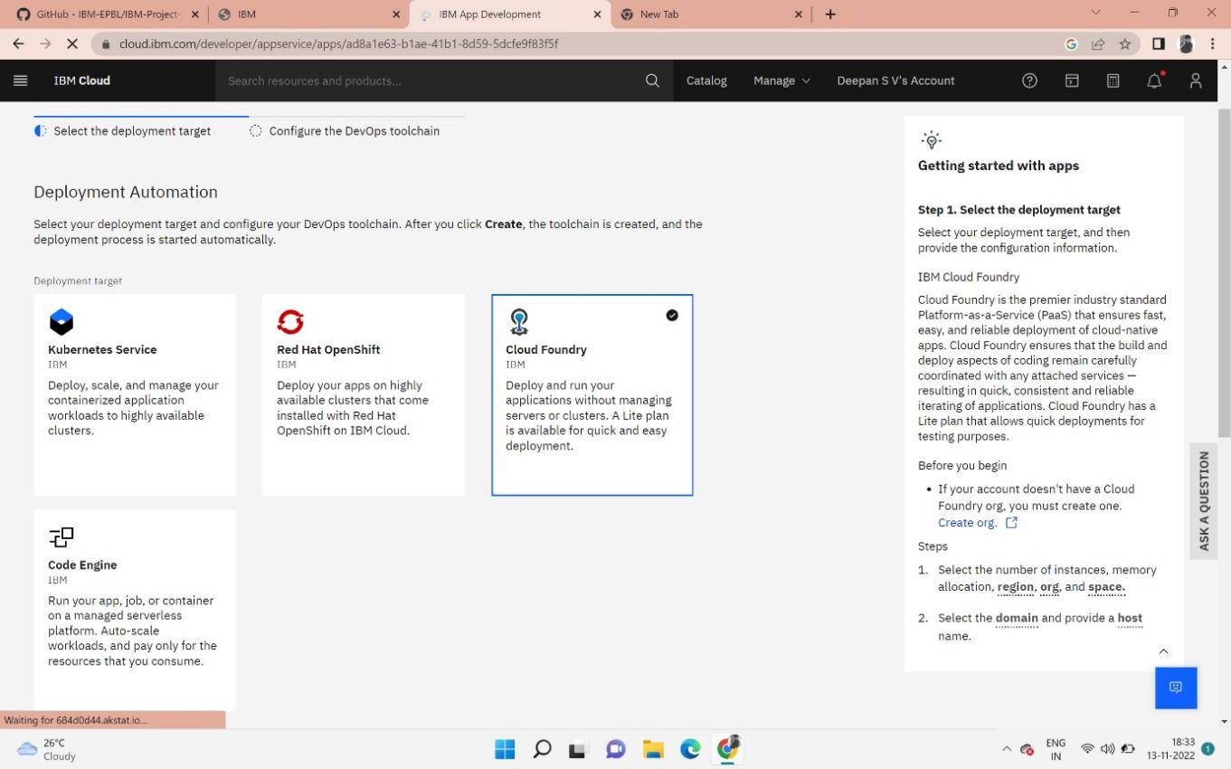

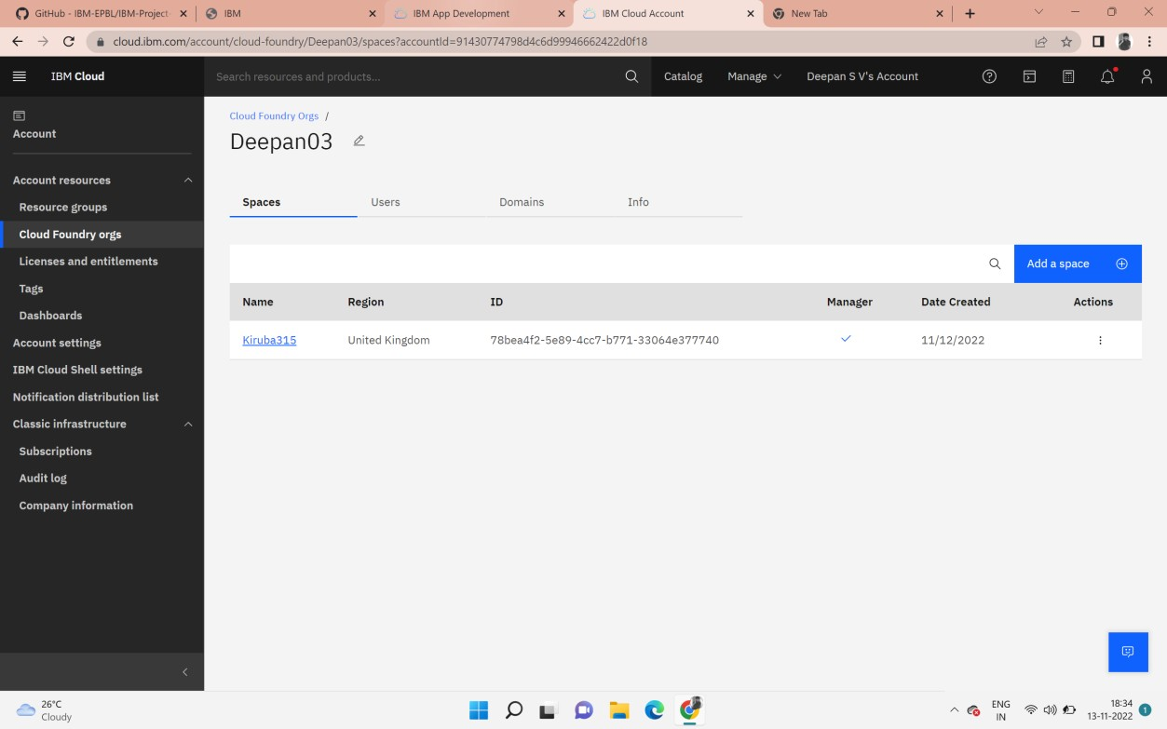

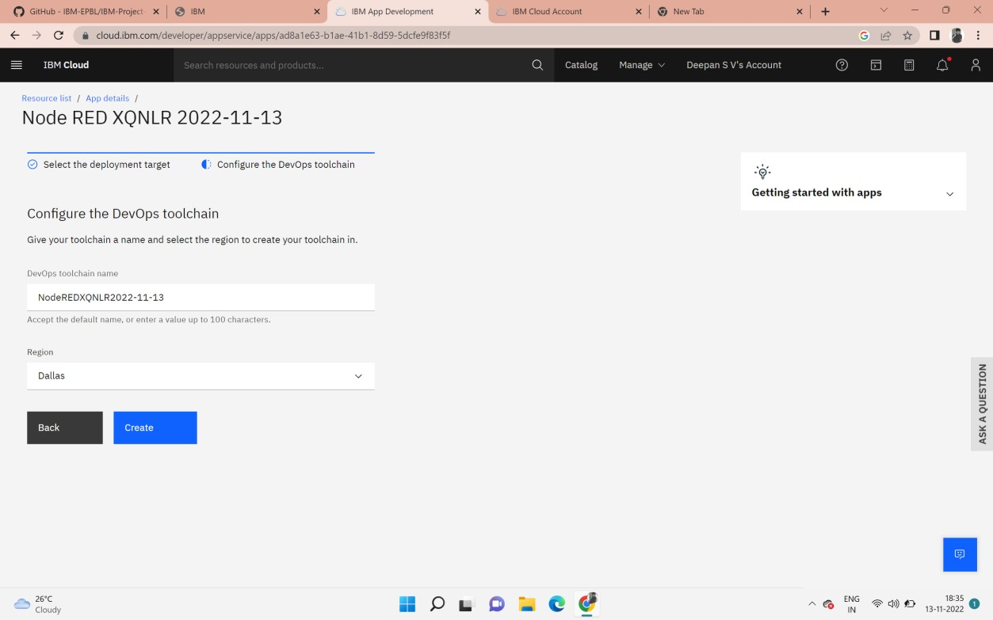

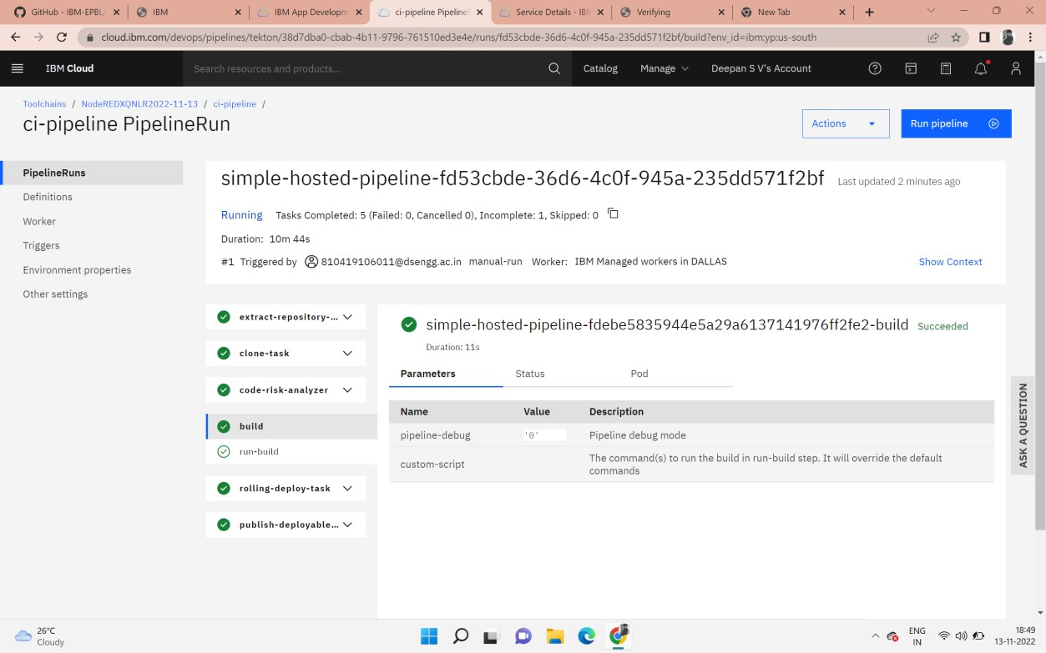

FINAL STEP CREATED NODE RED:

